SIMATS ENGINEERING (SAVEETHA SCHOOL OF ENGINEERING)
Department of Computer Science and Engineering

CO1 ASSESSMENT TOOL 1 – Case Study Analysis
Course Code: | CSA10 / CSA1005 | Course Title: | Software Engineering
CO Assessed: | CO1 | Assessment: | Assessment Tool 1 – Case Study Analysis
Weightage: | 20% | Total Marks: | 25
CO1 Statement: | Apply advanced methodologies and agile project management techniques to manage software projects effectively
Student Name: | Patteela Yashwanth Kumar | Reg. No.: | 192471055
Date: | 09-10-2026 | Duration: | 60 minutes

Code of Conduct
I Patteela Yashwanth kumar/19247105(Name / Reg No) certify that this submission is my original work and that I have adhered to the
guidelines specified for this assessment. I understand that any violation of academic integrity rules will result in disciplinary action.
Signature of the Student:Pattteela Yashwanth Kumar
Annexure A – Case Study Analysis
Instructions to Students:
Each student will be allotted one problem statement. Analyze the assigned problem systematically by following the steps given below. Your report should demonstrate your understanding of software engineering concepts and your ability to design an appropriate software solution.
Based on your allotted problem statement, prepare a report by answering the following questions:
- Understand the Problem Statement o Explain the problem in your own words. o Identify the objectives of the proposed system.
  - State the scope of the problem.
- Identify Key Stakeholders and Challenges o Identify all the stakeholders involved in the system. o Explain the roles and responsibilities of each stakeholder.
  - Discuss the major challenges and issues faced by the stakeholders.
- Analyze the Current Approach o Describe the existing system or current process. o Identify its strengths and limitations.
  - Analyze the problems or gaps that need to be addressed.
- Propose a Suitable Solution Using Software Engineering Principles o Design a software-based solution for the given problem.
  - Describe the major functional modules of the proposed system. o Identify the functional and non-functional requirements.
  - Explain how software engineering principles such as modularity, scalability, maintainability, reliability, usability, and security are incorporated into your solution.
- Justify the Chosen Methodology/Framework o Select an appropriate Software Development Life Cycle (SDLC) model or software development framework (e.g., Agile, Scrum, Waterfall, Spiral, DevOps). o Justify why the selected methodology/framework is suitable for the proposed system.
  - Explain how it supports successful project development and maintenance.
- Discuss Expected Outcomes and Limitations o Describe the expected benefits of the proposed solution. o Explain how the solution addresses the identified challenges. o Discuss potential risks, implementation challenges, and limitations. o Suggest possible future enhancements.
Rubrics for Calculation
Criteria | Excellent (5  Marks) | Good (3 Marks) | Satisfactory (2  Marks) | Needs  Improvement  (1 Mark)
Problem  Understanding  (30%) | Clearly explains the problem, objectives, and scope with complete understanding. | Explains the problem with minor omissions. | Basic understanding with limited explanation. | Poor understanding; objectives and scope are unclear or missing.
Stakeholder &  Challenge  Analysis (25%) | Identifies all stakeholders, their roles, and challenges with clear analysis. | Identifies most stakeholders and challenges with adequate analysis. | Identifies only a few stakeholders or challenges. | Stakeholders and system analysis are incomplete or inaccurate.
Current  System  Analysis (20%) | Thoroughly analyzes the existing system, strengths, weaknesses, and identifies all gaps. | Good analysis with most strengths and weaknesses identified. | Limited analysis with partial identification of issues. | Proposed  solution is unclear or inappropriate; requirements are largely missing.
Proposed  Software  Solution &  Software  Engineering  Principles  (15%) | Proposes an innovative, feasible solution applying appropriate software engineering principles (modularity, scalability, maintainability, security, etc.). | Suitable solution with good application of software engineering principles. | Basic solution with limited application of software engineering principles. | Methodology  is  inappropriate, poorly justified, or not discussed.
Methodology/  Framework  Justification  (10%) | Selects the most suitable  SDLC/model/fram ework and provides strong technical justification. | Suitable methodology selected with adequate justification. | Methodology selected but justification is weak. | Outcomes,  limitations, or future  enhancements are missing; report lacks organization and clarity.

Criteria | Mark
Problem Understanding (30%) | /5
Stakeholder & Challenge Analysis (25%) | /5
Current System Analysis (20%) | /5
Proposed Software Solution & Software  Engineering Principles (15%) | /5
Methodology/ Framework Justification  (10%) | /5
TOTAL | /25

CASE STUDY ANALYSIS
Smart Donation and Charity Management Platform

1. Understanding the Problem Statement
Problem : Charitable organizations receive money, food, clothing, equipment and other resources from many individuals and institutions. In most organizations these contributions are recorded manually or in scattered spreadsheets, and distribution to needy people is poorly documented. Donors therefore cannot see how their contribution was used, which weakens trust and reduces repeat giving, while staff spend long hours on paperwork. The problem is to design one digital platform that records every donation, manages beneficiaries, tracks distribution of resources, maintains accurate financial records and lets donors follow the impact of their contribution in a transparent way.
Objectives of the proposed system:
- Register donors and create donation campaigns with targets and deadlines.
- Record monetary and in-kind donations and generate automatic donation receipts.
- Manage beneficiary information and track resource distribution.
- Provide donor dashboards and track campaign performance.
- Maintain accurate financial records and generate transparency reports.
- Reduce administrative effort and improve donor confidence.
Scope of the problem:
- In scope: donor, campaign, donation, beneficiary, distribution, inventory, receipt, finance and reporting modules for a charity organization, delivered as a web portal with a mobile-friendly interface.
- Out of scope: direct filing with government tax portals, vehicle/logistics fleet management and full payroll or accounting software (these can be integrated in later releases).
- Users: donors, administrators, finance staff, volunteers and auditors. Beneficiaries are managed as records by staff, though they may later get a self-service view.

2. Key Stakeholders and Challenges
Stakeholder | Roles and Responsibilities | Major Challenges
Donors  (individuals / institutions) | Register, donate to campaigns, track usage of funds, download receipts and tax certificates. | No visibility of fund usage; fear of misuse; delayed or lost receipts.
Charity  Administrator /  Manager | Create campaigns, verify donations, approve distribution, monitor performance, prepare reports. | Heavy manual work, duplicate records, difficulty compiling reports on time.
Finance /  Accounts Team | Maintain income-expense records, reconcile payments, support audits. | Mismatch between donations and ledgers; error-prone manual entries.
Volunteers / Field  Staff | Collect in-kind items, deliver resources, update distribution status. | No real-time stock information; poor coordination; paper-based updates.
Auditors /  Regulators | Verify compliance and audit financial statements. | Incomplete audit trails; difficulty verifying where funds went.
Payment Gateway  / IT Team | Process online payments; develop, host and maintain the system. | Payment security, downtime, data-protection compliance, cost of maintenance.

Overall challenges: lack of transparency, inaccurate or duplicated data, inefficient distribution, privacy and security of donor and beneficiary data, high administrative workload and low donor trust.

3. Analysis of the Current Approach
Existing system / process: Donations arrive as cash, cheques, bank transfers or physical goods and are noted in paper registers, Excel sheets or basic accounting tools. Receipts are handwritten or emailed manually, beneficiary lists are kept on paper, stock of goods is counted by hand, and financial or impact reports are prepared only at the end of the year.
Strengths | Limitations
Simple and low cost to run. | Records are scattered and inconsistent, causing duplication, loss and human error.
Familiar to staff; little training needed. | No link between a donation and its final distribution, so donors cannot track impact.
Works without internet or special infrastructure. | In-kind donations are not tracked by quantity, category or expiry date.
Direct personal contact with donors and beneficiaries. | Manual receipts and reports delay reconciliation and audits.
Flexible for small and informal charities. | Weak access control, no audit trail, higher risk of misuse and fraud.

Problems and gaps to be addressed:
- Absence of a centralized database and real-time information.
- No transparency to donors and no donor engagement or feedback mechanism.
- No beneficiary verification, so the same person may receive help more than once while others are missed.
- No analytics on campaign performance to support planning and decision making.
- The process does not scale as the number of donors, campaigns and beneficiaries grows.

4. Proposed Software Solution Using Software Engineering Principles
Design of the solution: A web-based, three-tier platform: (1) Presentation layer – donor portal, admin dashboard and responsive mobile view; (2) Application layer – modular business services exposed through REST APIs with role-based security; (3) Data layer – relational database (e.g., MySQL/PostgreSQL) with integrations for a payment gateway, email/SMS notification service and cloud hosting. Typical flow: Donor registers → chooses a campaign → donates → system records the payment and issues a receipt → admin allocates resources to verified beneficiaries → volunteers update delivery status → finance ledger and dashboards update automatically → transparency report is published.
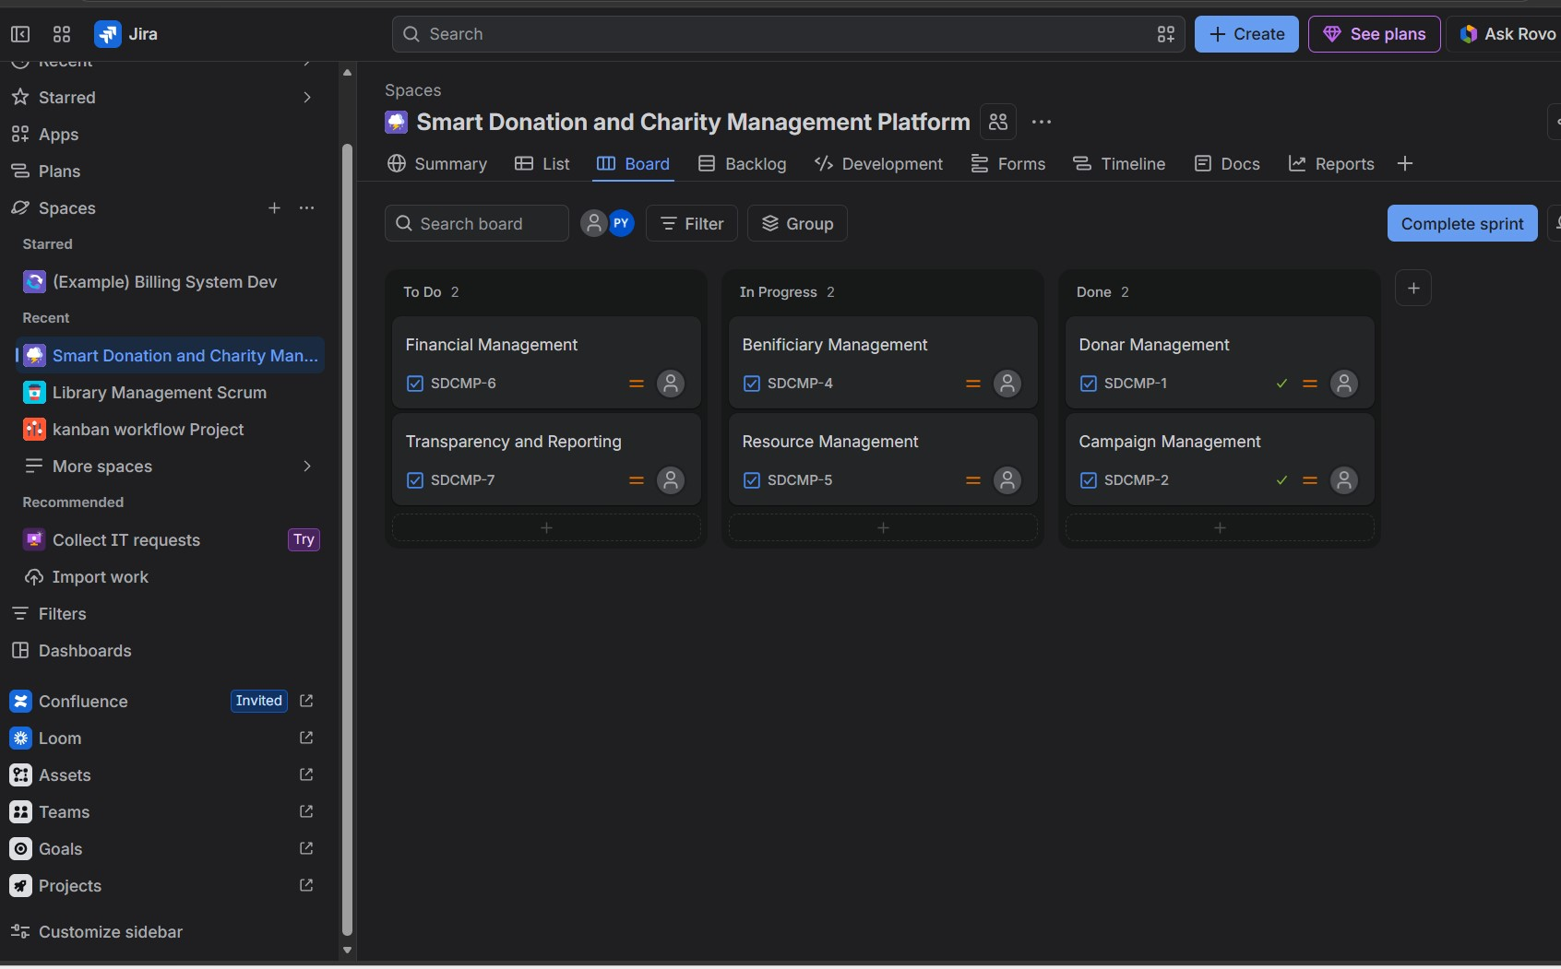

Major functional modules:
Module | Function
Donor Management | Registration, login, profile, donation history, donor dashboard showing fund utilization.
Campaign Management | Create/edit campaigns, targets, deadlines, categories, progress tracking, performance tracking.
Donation Management | Record cash, online and in-kind donations; payment integration; automatic receipt generation.
Beneficiary Management | Registration, eligibility verification, duplicate detection, need assessment, history of aid.
Distribution & Inventory | Allocate and track resources, stock levels, delivery status, volunteer assignment.
Finance Management | Income-expense ledger, reconciliation, fund-wise balances, financial records.
Reports & Analytics | Transparency reports, campaign performance, donor impact, audit logs, export to PDF/Excel.
Admin & Security | User roles, authentication, audit trail, notifications, system configuration.

Functional Requirements | Non-Functional Requirements
FR1: Register and authenticate donors, staff and volunteers. | NFR1 Performance: pages respond within 3 seconds for normal load.
FR2: Create and manage donation campaigns. | NFR2 Availability: at least 99% uptime with daily backups.
FR3: Record monetary and in-kind donations. | NFR3 Security: encryption, role-based access, audit logs.
FR4: Generate donation receipts automatically. | NFR4 Scalability: supports growth in users and campaigns.
FR5: Manage beneficiaries and verify eligibility. | NFR5 Usability: simple interface, mobile compatibility.
FR6: Track resource distribution and inventory. | NFR6 Reliability: no data loss; safe transaction handling.
FR7: Provide donor dashboards and notifications. | NFR7 Maintainability: modular, documented, easy to update.
FR8: Maintain financial records and reconciliation. | NFR8 Compliance: data-protection and audit requirements.
FR9: Generate transparency and performance reports. | NFR9 Portability: works on all major browsers and devices.

Software engineering principles incorporated:
- Modularity: independent modules with well-defined interfaces and low coupling, so each can be developed, tested and replaced separately.
- Scalability: stateless services, cloud deployment, load balancing and database indexing allow growth in donors and transactions.
- Maintainability: layered architecture, coding standards, documentation, version control (Git) and automated tests make changes easy.
- Reliability: transaction management, automated backups, exception handling and multi-level testing (unit, integration, system, UAT).
- Usability: simple dashboards, clear navigation, responsive design, one-click receipt download and notifications.

5. Justification of the Chosen Methodology: Agile (Scrum)
Selected framework: Agile using the Scrum framework. The charity manager acts as Product Owner, a team member as Scrum Master, and the developers and testers form the development team. Work is delivered in 2-week sprints from a prioritized product backlog.
Why Agile (Scrum) is suitable:
- Requirements will evolve as donors, charity staff and auditors give feedback; Agile welcomes change, whereas Waterfall freezes requirements early.
- The modules are largely independent, so they can be released incrementally and start giving value early.
- Sprint reviews involve stakeholders regularly, reducing the risk of building the wrong features.
- The charity has limited budget and time; small increments reduce cost and risk.
- Continuous testing and integration give high quality and reliability for a system that handles money.

Comparison with other models:
Model | Fit for this project | Reason
Waterfall | Low | Rigid; changes after requirement phase are costly; late delivery.
Spiral | Medium | Good for risk analysis but heavy documentation and costly for a small team.
Agile (Scrum) | High (selected) | Iterative, flexible, stakeholder involvement, early working releases.
DevOps | Supporting | Used along with Agile for CI/CD, automated deployment and monitoring.

Sample sprint plan:
Sprint | Planned Deliverables
Sprint 1 | Requirements, architecture, database design, donor registration and login.
Sprint 2 | Campaign management, donation recording, payment integration, receipt generation.
Sprint 3 | Beneficiary management, distribution and inventory tracking.
Sprint 4 | Finance module, donor dashboard, transparency reports and campaign analytics.
Sprint 5 | Security testing, performance testing, UAT, deployment and training.

Support for development and maintenance: The product backlog, daily stand-ups, sprint reviews and retrospectives keep the team aligned and continuously improving.

6. Expected Outcomes and Limitations
Expected benefits and how the solution addresses the challenges:
Challenge | How the Solution Addresses It
Lack of transparency | Donor dashboards and transparency reports show how funds and goods were used.
Low donor trust | Instant receipts, impact tracking and audit trails build confidence and repeat giving.
Inefficient distribution | Verified beneficiary records and inventory tracking enable fair and timely allocation.
High administrative effort | Automation of records, receipts and reports saves staff time.
Inaccurate finances | A central ledger with reconciliation gives accurate, audit-ready financial records.
No performance insight | Campaign analytics support better planning and improved charity management.

Potential risks, implementation challenges and limitations:
Risk / Limitation | Mitigation
Data breach or payment fraud | Encryption, role-based access, PCI-compliant gateway, regular security audits.
Low digital literacy of staff or donors | Training sessions, simple interface, user manuals and help desk.
Internet dependency in rural areas | Mobile-friendly design, offline data entry with later synchronization.
Scope creep and budget overrun | Prioritized backlog, fixed sprint scope, regular stakeholder review.
Resistance to change | Early involvement of staff, phased rollout and demonstrations of benefits.
Ongoing cost and compliance | Cloud-based pay-as-you-grow hosting; periodic review of data-protection rules.

Future enhancements: blockchain-based immutable donation ledger; AI-based fraud detection and donor recommendations; native Android/iOS app; multi-language support; QR/UPI and international payments; integration with government and tax portals (e.g., 80G certificates); real-time GPS tracking of deliveries; chatbot support; and donor social-sharing features.

Conclusion: The proposed Smart Donation and Charity Management Platform, developed using Agile Scrum and sound software engineering principles, replaces manual and fragmented processes with a transparent, secure and scalable system. It builds donor trust, reduces administrative effort and ensures that help reaches the right beneficiaries efficiently.

